Design Assignment 3

Student Name: Bruce Moquete

Student #: 1013123266

Student Email: moquete@unlv.nevada.edu

Primary Github address: https://github.com/dcon99/CMX2345.git

Directory: All Design Assignments/DA3

1. **COMPONENTS LIST AND CONNECTION BLOCK DIAGRAM w/ PINS**

Atmega328P & Atmel Studio 7.0 Terminal

1. **INITIAL/MODIFIED/DEVELOPED CODE OF TASK 3A**

/*

This program is meant to demonstrate basic USART usage of the ATmega328p by transmitting

a string, a random integer, and a random double number over a serial port every second (roughly)

by using Timer1.

*/

#define *F_CPU* 8000000UL //Sets the clock speed of the MCU

#define BAUD 9600 //Sets the baud rate for the UART to transmit

#define BAUDRATE ((*F_CPU*) / (BAUD * 8UL)-1) // Set Baud Rate Value for UBRR

/////////////////////////////////////////////////////////////////////////////////////////////////////

#include <avr/io.h>

#include <util/delay.h>

#include <avr/interrupt.h>

#include <stdlib.h>

#include <stdio.h>

/////////////////////////////////////////////////////////////////////////////////////////////////////

char String[]="Hello world!!"; //Character array for string

char LineBreak[]="\r\n"; //New line and return string array for a neater transmission

unsigned int number = 65; //Int declared for UART

double n = 1.3689; //Double/Float declared for UART

char String_num[]; //String array to hold an int after converting to string for int

char String_flt[]; //String array to hold a double value after converting to string

volatile *uint8_t* time_ovf; //Integer to hold the amount of times the timer overflows

/////////////////////////////////////////////////////////////////////////////////////////////////////

//A function used to initialize Timer1 of the ATmega328P with a prescale of 64

void timer1_init()

{

//Set up timer with a prescale of 64

TCCR1A |= (0<<COM1A1) | (0<<COM1A0);

TCCR1B |= (1<<CS11)|(1 << CS10);

//Initialize counter

TCNT1 = 0;

//Enable overflow interrupt

TIMSK1 |= (1 << TOIE1);

//Initialize overflow counter variable

time_ovf = 0;

}

//Used to initialize the UART of the ATmega328P with a baud rate of 9600 and enables global interrupts.

void initialize_UART(){

UBRR0H = (*uint8_t*)(BAUDRATE>>8);

UBRR0L = (*uint8_t*)(BAUDRATE);

UCSR0B = (1<<RXEN0)|(1<<TXEN0);

UCSR0C = ((1<<UCSZ00)|(1<<UCSZ01));

sei();

}

//Function used to send one character (8-bits) at a time through USART

void USART_send( unsigned char data){

while(!(UCSR0A & (1<<UDRE0)));

UDR0 = data;

}

//Function used to send converted numbers through a string array through USART

void USART_send_num( unsigned int data){

while(!(UCSR0A & (1<<UDRE0)));

UDR0 = data;

}

//Function used to receive data from USART

unsigned char USART_receive(void){

while(!(UCSR0A & (1<<RXC0)));

return UDR0;

}

//Function used to transmit an array of characters (string) through USART one character at a time.

void USART_putstring(char* StringPtr){

while(*StringPtr != 0x00){

USART_send(*StringPtr);

StringPtr++;}

}

//Function used to transmit an array of characters of an integer converted into a string through USART one character at a time.

void USART_putnumber(char* String_num){

String_num = (*utoa*(number,String_num,10)); //Converts an int to a string

while(*String_num != 0x00){

USART_send_num(*String_num);

String_num++;}

}

//Function used to transmit an array of characters of an double converted into a string through USART one character at a time.

void USART_putflt(char* String_flt){

String_flt = *dtostrf*(n,0,4,String_flt); //Converts a double to a string

while(*String_flt != 0x00){

USART_send_num(*String_flt);

String_flt++;}

}

//Interrupt Service Routine used for Timer1 Overflow.

ISR(TIMER1_OVF_vect)

{

//Keep track of number of overflows

time_ovf++;

}

/////////////////////////////////////////////////////////////////////////////////////////////////////

int main(void)

{

initialize_UART(); //Initializes UART

timer1_init(); //Initializes Timer1

while (1)

{

if(time_ovf >= 4){

USART_putstring(String);

USART_putstring(LineBreak);

USART_putstring(LineBreak);

USART_putnumber(String_num);

USART_putstring(LineBreak);

USART_putstring(LineBreak);

USART_putflt(String_flt);

USART_putstring(LineBreak);

USART_putstring(LineBreak);

TCNT1 = 0;

time_ovf = 0;

}

else;

}

}

1. **DEVELOPED MODIFIED CODE OF TASK 2/A from TASK 1/A**

N/A

1. **SCHEMATICS**

N/A

1. **SCREENSHOTS OF EACH TASK OUTPUT (ATMEL STUDIO OUTPUT)**

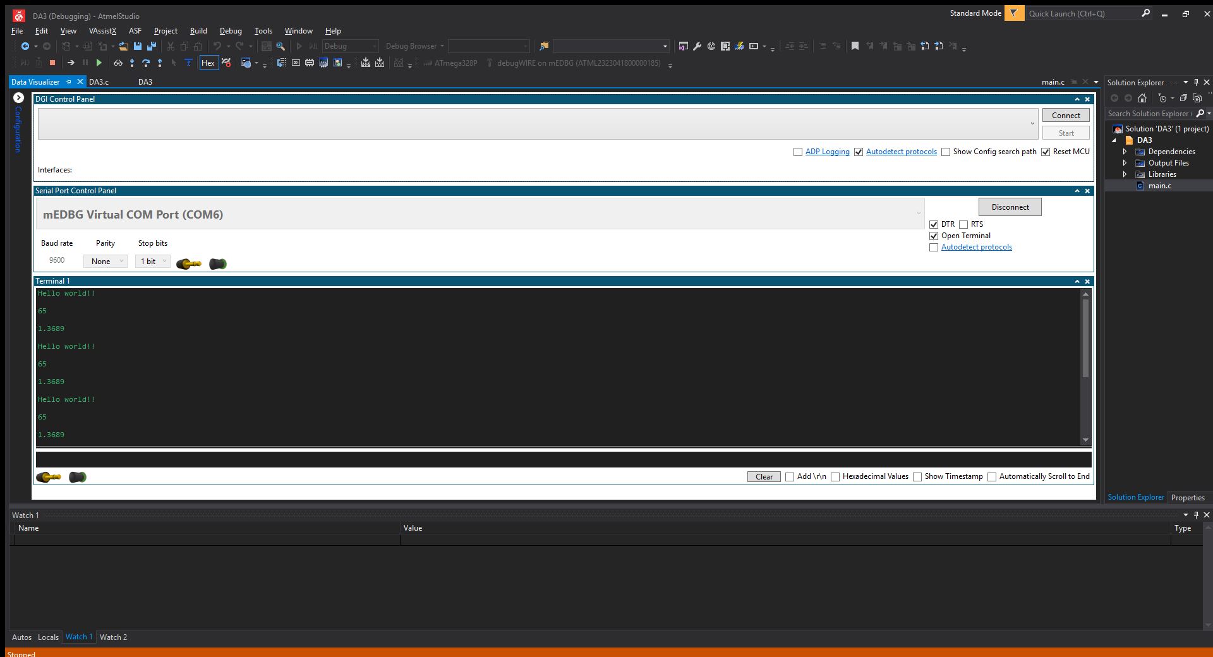

1. **SCREENSHOT OF EACH DEMO (BOARD SETUP)**

N/A

1. **VIDEO LINKS OF EACH DEMO**

<https://youtu.be/ytiYKfC2-j8> (Unlisted)

1. **GITHUB LINK OF THIS DA**

https://github.com/dcon99/CMX2345.git

**Student Academic Misconduct Policy**

<http://studentconduct.unlv.edu/misconduct/policy.html>

“This assignment submission is my own, original work”.

NAME OF THE STUDENT